

|  |
| --- |
| How to use  SIM trading simulator |
| Execution Server (Ember) |

# Overview

This document describes how to use SIM trading connector.

Ember ships with two services that can be used to simulate order execution:

* **SIMULATOR** – special algorithm that provides **realistic** order execution. The algorithm uses QuoteFlow library to maintain state of the markets and estimate accurate order execution. See QuoteFlow documentation for more information.
* **SIM** – special trading connector that can replay some simple execution scenarios, for example simple fill at limit price, or order reject. See the rest of this document for more information.

# Configuration

The following config stanza shows how to enable SIM trading connector in ember.conf[1]:

connectors {

SIM: ${sim}

}

# Order routing

Specify SIM as order **destination** to send orders to this simulator.

SIM supports multiple order execution scenarios. Simple scenarios can be specified using **exchange** order field. For more complex scenarios you can use custom order attribute SimScript(7001).

## Simple Scenarios

|  |  |
| --- | --- |
| Exchange | Description of SIM behavior |
| REJECT | Instant reject. SIM immediately rejects the order. |
| CANCEL | Instant cancel. SIM immediately cancels the order. |
| FILL | Instant fill. SIM immediately fills entire order. Fill will be using limit price or stop price (when provided), or **dummy price $1234**. |
| CORRECT | Simulator will issue a FILL event, immediately followed by FILL CORRECTION |
| BUST | Simulator will issue a FILL event, immediately followed by FILL CANCELLATION (BUST) |
| ACK,FILL | Similar to FILL, but the Simulator will issue order acknowledgement event prior to fill. |
| ACK,CANCEL | Similar to CANCEL, but the Simulator will issue order acknowledgement event prior to cancel. |
| ACK,REJECT | Similar to REJECT, but the Simulator will issue order acknowledgement event prior to reject. |
| CANCELRJCT | O |
| CANCELFILL | Exceptional scenario: order will be reported as CANCELLED, followed by FILL event (abnormal order state transition that may happen on some exchanges, like Eurex). |
| BLACKHOLE | “Black Hole” – no events will be issued for the order. |
| ACK | Order will receive acknowledgement event and nothing else. |
| RESTATE | Simulator will acknowledge order, then report “order restate event”. Can be used to test stop / stop-limit order trigger behavior. |
| TFILL | Very similar to FILL, but the fill will be reported using “total quantity/average price” reporting method (used by some exchanges). This can be used to test OMS functionality (Ember OMS converts such fills to normal incremental fills for algorithms and clients. |
| SCRIPT | See the next section. |

Exchange values are case sensitive, trailing / inner / leading spaces are not allowed.

## Scripting order execution

For users who want more flexibility SIM provides an ability to specify what exact events should be issued for order. You can also specify how events should be delayed (to simulate order transmission or execution delay).

|  |  |
| --- | --- |
| Exchange | Description of SIM behavior |
| SCRIPT | Executes order according to script specified by custom order request attribute 7001. |

Attribute 7001 contains **comma separated events** that should be issued for order (left to right). The following events are supported:

|  |  |  |
| --- | --- | --- |
| Exchange | Description of SIM behavior | Optional parameters |
| ACK | Order acknowledgement event (OrderPendingNewEvent) | N/A |
| OPEN | Order is open on exchange (OrderNewEvent) | N/A |
| CANCEL | Order cancel confirmation event (OrderCancelEvent) | Order cancellation reason.  For example:  CANCEL:Cancelled by exchange |
| REJECT | Order rejection event (OrderRejectEvent) | Order rejection reason  For example:  REJECT:Market is closed |
| CANCELRJCT | Order Cancel Reject (OrderCancelRejectEvent) | Order cancellation reject reason.  For example:  CANCELRJCT:Too early to cancel |
| FILL | Order fill event (complete or partial) | The first optional argument is fill quantity (by default entire order), the second optional argument is fill price (by default limit or stop price of the order).  For example:  FILL  FILL:100:123.45  FILL:50 |
| CORRECT | Fill correction event (OrderTradeCorrectionEvent) | Index of fill event to correct (zero-based). Identifies previous fill event. By default, the first fill event will be corrected.  For example:  CORRECT  CORRECT:1  Just like for FILL the first optional argument is corrected fill quantity (by default entire order), the second optional argument is corrected fill price (by default limit or stop price of the order) |
| BUST | Fill cancellation event (OrderTradeCancelEvent) | Index of fill event to cancel (zero-based). Identifies previous fill event. By default, the first fill event will be cancelled.  For example:  BUST  BUST:1 |
| RESTATE | Issues order restate event (OrderRestateEvent). For example, for triggered stop order. | N/A |
| DELAY | Delay prior to the next event in the script | Parameter specifies delay duration. If duration is not specified, one second delay is used.  Intervals can be measured in the following units:   |  |  | | --- | --- | | Milliseconds (X) | "10X" = 10 milliseconds | | Seconds (S) | "10S" = 10 seconds | | Minutes (I) | "10I" = 10 minutes | | Hours (H) | "10H" = 10 hours | |

The following screenshot shows how to submit SCRIPT order to SIM using Ember Monitor:

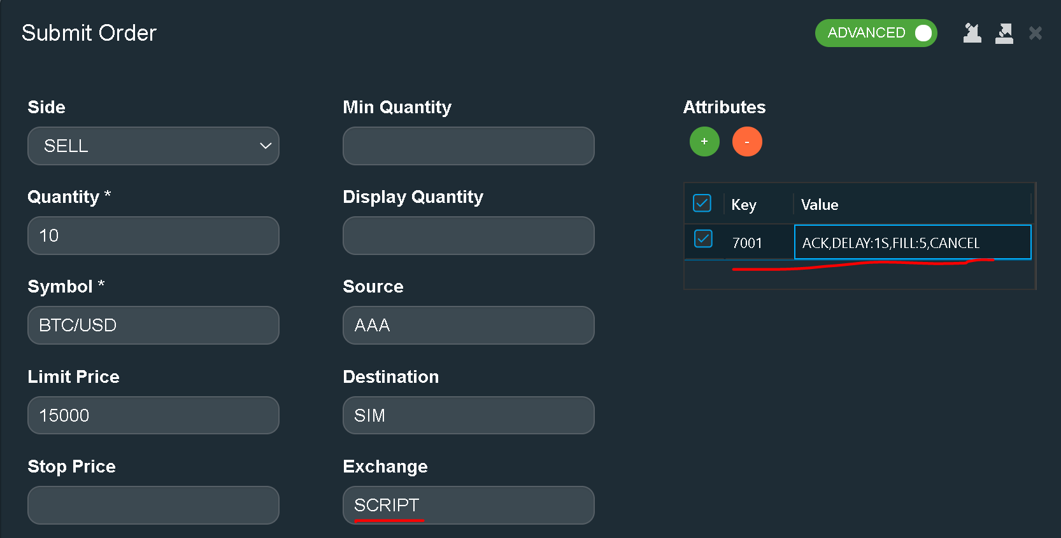

Complete examples of execution simulation scripts:

|  |  |
| --- | --- |
| REJECT:Bad price | Order reject event with “bad price” rejection reason |
| OPEN,FILL | Order complete fill after order becomes open on exchange |
| OPEN,FILL:5 | Same as above, but order is filled only for quantity equals to 5 |
| FILL:5:123.45 | Order is filled without intermediary OPEN event; fill quantity is 5; fill price is 123.45 |
| OPEN,FILL:900,CANCEL | partial fill of size 900, followed by Cancel message (missing fill of 100 assuming that order size is 1000) |
| DELAY:1S,ACK,DELAY:5S,FILL | Initial order acknowledgement event is delayed by 1 second after order submission. Fill is delayed 6 seconds (1+5). |
| OPEN,CANCEL,FILL | Example of abnormal “fill after cancel” order workflow |
|  | Empty script will result in no events. This is abnormal – typically all order destination venues are required to provide some kind of feedback events for each order. |

| REVISION HISTORY | | | | | |
| --- | --- | --- | --- | --- | --- |
| Ver. | Description of Change | Author | Date | Approved | |
| Name | Effective Date |
| 0.1 | Initial Version | Andy Malakov | 29-Sept-2020 |  |  |
| 0.2 | Added SCRIPT exchange description | Andy Malakov | 20-Nov-2020 |  |  |
|  |  |  |  |  |  |

1. See Ember Configuration Reference guide for more information about ember.conf configuration file.